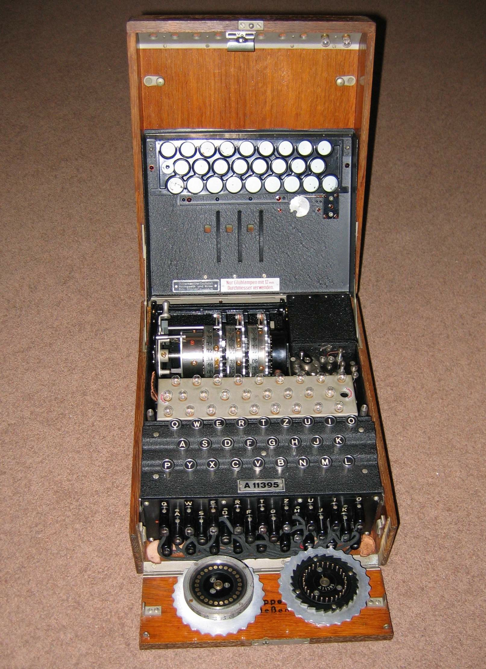
Newcastle University
School of Computing Science

Alan Turing: Computing Pioneer

http://www.ncl.ac.uk/computing/about/events/Main/Turing/

Wednesday 14th November 2012
2.00 pm - 6.30 pm
Curtis Auditorium, Herschel Building

To celebrate the centenary of the birth of Alan Turing, the School of Computing Science will host a seminar at which speakers will give presentations on aspects of his work. The seminar is intended primarily for computing students, but is also open to members of the public. Our speakers have all made invited contributions to a number of other events in the Alan Turing Year, including major conferences at both Oxford and Cambridge.

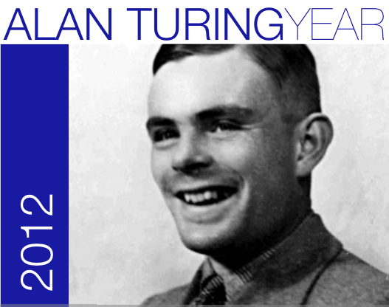
Newcastle University
This event is part of the ‘Alan Turing Year’

See the events page at:
http://www.mathcomp.leeds.ac.uk/turing2012/

School of Computing Science

Alan Turing: Computing Pioneer

http://www.ncl.ac.uk/computing/about/events/Main/Turing/

Wednesday 14th November 2012
2.00 pm - 6.30 pm
Curtis Auditorium, Herschel Building

To celebrate the centenary of the birth of Alan Turing, the School of Computing Science will host a seminar at which speakers will give presentations on aspects of his work. The seminar is intended primarily for computing students, but is also open to members of the public. Our speakers have all made invited contributions to a number of other events in the Alan Turing Year, including major conferences at both Oxford and Cambridge.

This event is part of the ‘Alan Turing Year’

See the events page at:
http://www.mathcomp.leeds.ac.uk/turing2012/

Confirmed speakers, and indicative titles are:

Turing, Lovelace and Babbage
Dr Doron Swade MBE (formerly Assistant Director, Science Museum)
Doron Swade is a leading authority on the history of computing, especially the works of Charles Babbage. He masterminded the Science Museum's 17-year project to construct Babbage's Difference Engine No. 2 from the original designs.

Turing in the History of Software
Professor Cliff Jones (Newcastle University)
Cliff Jones is a leading theoretical computer scientist who has written about Turing's role in the early development of software and his contributions to program correctness. This talk will look at Turing's impact on the evolution of software including a discussion of a little known 1949 paper whose wider dissemination might have significantly accelerated what is now an important topic in computing science.

Alan Turing's Other Universal Machine: The ACE
Professor Martin Campbell-Kelly (Warwick University)
Martin Campbell Kelly has written extensively on the history of computers, and is the editor of the Collected Works of Charles Babbage. He is a member of the editorial board of the Annals of the History of Computing, and Editor in Chief of the Springer Series on the History of Computing.

A Turing Enigma
Professor Brian Randell (Newcastle University)
In the course of undertaking research for his book "On the Origins of Digital Computers" (1976) - a book which has been described as having "founded the discipline of the History of Computing" - Brian Randell became aware of the development at Bletchley Park of the world's first electronic digital computer, Colossus, and Alan Turing's role in it. His presentation "The Colossus" at the First International Conference on the History of Computing at Los Alamos in 1976 was the first non-secret account.

To indicate your attendance, please visit the event web page at:
http://www.ncl.ac.uk/computing/about/events/Main/Turing/
or call Claire Smith on 0191 222 7999
Confirmed speakers, and indicative titles are:

Turing, Lovelace and Babbage
Dr Doron Swade MBE (formerly Assistant Director, Science Museum)
Doron Swade is a leading authority on the history of computing, especially the works of Charles Babbage. He masterminded the Science Museum's 17-year project to construct Babbage's Difference Engine No. 2 from the original designs.

Turing in the History of Software
Professor Cliff Jones (Newcastle University)
Cliff Jones is a leading theoretical computer scientist who has written about Turing's role in the early development of software and his contributions to program correctness. This talk will look at Turing's impact on the evolution of software including a discussion of a little known 1949 paper whose wider dissemination might have significantly accelerated what is now an important topic in computing science.

Alan Turing's Other Universal Machine: The ACE
Professor Martin Campbell-Kelly (Warwick University)
Martin Campbell Kelly has written extensively on the history of computers, and is the editor of the Collected Works of Charles Babbage. He is a member of the editorial board of the Annals of the History of Computing, and Editor in Chief of the Springer Series on the History of Computing.

A Turing Enigma
Professor Brian Randell (Newcastle University)
In the course of undertaking research for his book "On the Origins of Digital Computers" (1976) - a book which has been described as having "founded the discipline of the History of Computing" - Brian Randell became aware of the development at Bletchley Park of the world's first electronic digital computer, Colossus, and Alan Turing's role in it. His presentation "The Colossus" at the First International Conference on the History of Computing at Los Alamos in 1976 was the first non-secret account.

To indicate your attendance, please visit the event web page at:
http://www.ncl.ac.uk/computing/about/events/Main/Turing/
or call Claire Smith on 0191 222 7999

